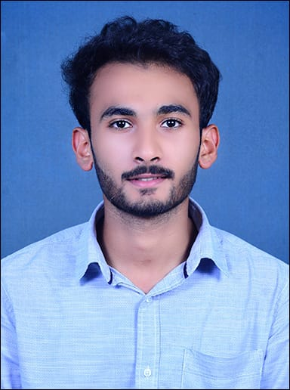Mohammed Khaif K Shaikh

3-105, Al- sheik manzil tenka yermal

behind old panchayat office

mohammedkhaifkshaikh7@gmail.com

6362223955

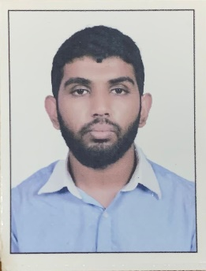

Mohammed Saheel Shaikh

6-17 yermal thenka ,gijji house

[Sahilsheakh86@gmail.com](mailto:Sahilsheakh86@gmail.com)

9686299711

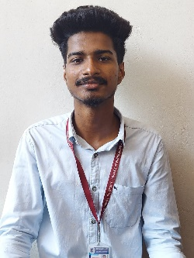Mohammad Shahil

16-33 Kal pande house karnad mulki

mohdshahilsidd74@gmail.com

7204756123

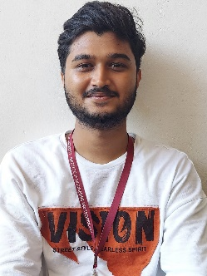Ismail Rahib

1/96, mukri house

near narayana guru hospital karnad mulki

irahib76@gmail.com

8431858133